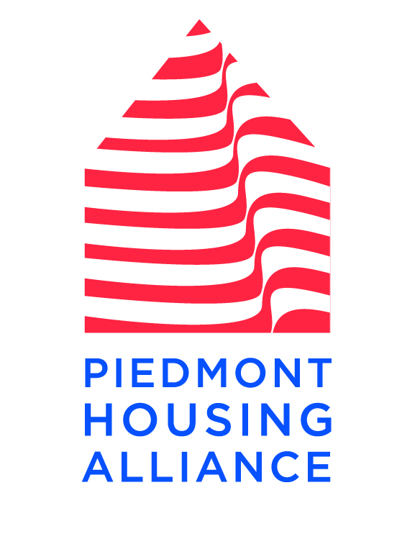
Piedmont Housing Alliance

1215 E. Market St. Ste. B
Charlottesville, VA 22902

(434) 817-2436
(434) 817-0664 Fax

www.piedmonthousingalliance.org
News
Release

April 3, 2015 FOR IMMEDIATE RELEASE

CONTACT: Karen Reifenberger, Deputy Director of Piedmont Housing Alliance (434) 817-2436, ext. 106; karenr@piedmonthousing.org

ACTIVITIES HIGHLIGHT FAIR HOUSING MONTH IN CHARLOTTESVILLE

CHARLOTTESVILLE, VA – April is “Fair Housing Month,” and the Fair Housing Program at Piedmont Housing Alliance has a schedule of activities to bring attention to the issue of housing discrimination and what we all can do to promote fair housing.

- On Thursday, April 23rd from 12:30-2 pm, Piedmont Housing Alliance is conducting a Fair Housing Workshop for People with Disabilities and Advocates. The workshop will take place at the Independence Resource Center, 815 Cherry Avenue in Charlottesville.
- On Wednesday, April 29 , Piedmont Housing, in partnership with the Charlottesville Office of Human Rights, will hold a Fair Housing Film Screening & Discussion from 6-7 pm in the Charlottesville City Council Chambers.
- On Tuesday, May 12, Piedmont Housing Alliance is hosting a Fair Housing Training by Mally Mason of the Virginia Fair Housing Office. The training takes place from 2-5 pm at TJPDC’s Water Street Center, 407 E. Water Street in Charlottesville.

More information about each of these activities is available on Piedmont Housing’s website, www.piedmonthousingalliance.org.

The federal Fair Housing Act prohibits housing discrimination based on race, color, national origin, sex, religion, familial status, or disability (and elderliness under Virginia’s Fair Housing Law), and makes it illegal to deny housing or treat someone differently based on disability in the rental, sale, or financing of housing. The Act requires that housing providers make reasonable accommodations in rules, policies, practices, or services when such accommodations may be necessary to afford a person with a disability the equal opportunity to use and enjoy a dwelling, and also requires that housing providers allow reasonable modifications to dwelling units to make them accessible. Further, multifamily housing must be designed and built according to seven basic accessibility requirements.

Piedmont Housing Alliance is an affordable housing non-profit working in the Thomas Jefferson Planning District in Central Virginia, including the city of Charlottesville and Albemarle, Fluvanna, Greene, Louisa, and Nelson counties. The mission of Piedmont Housing is to create housing opportunities and build community through education, lending and development. Piedmont Housing is a HUD-certified housing counseling agency, state-certified Community Housing Development Organization, and US Treasury certified Community Development Financial Institution. In 2002, Piedmont Housing became a part owner of the Friendship Court Apartments, where it now provides service coordination through the HUD-certified Neighborhood Networks Center.

