Don’t Be a Victim of Housing Discrimination
Under Fair Housing Law: In Virginia, it is illegal to be denied or treated differently in trying to rent or buy housing because of your:
- Race
- Color
- Religion
- National Origin
- Sex
- Disability
- Children in your family
- Elderliness (55 and older)
It is not always obvious - if the landlord gives you the runaround or says:
“We don’t take kids”
“The apartment you asked about on the phone has been rented”
“We only take people who speak English clearly”
“We don’t take teenagers”
“The ad was wrong – the rent is really $50 more”
“I can’t assign you a handicap parking space”

It could be HOUSING DISCRIMINATION.
The only way to stop it is to report it.
So call Piedmont Housing Alliance’s Fair Housing Program at (434) 817-2436.
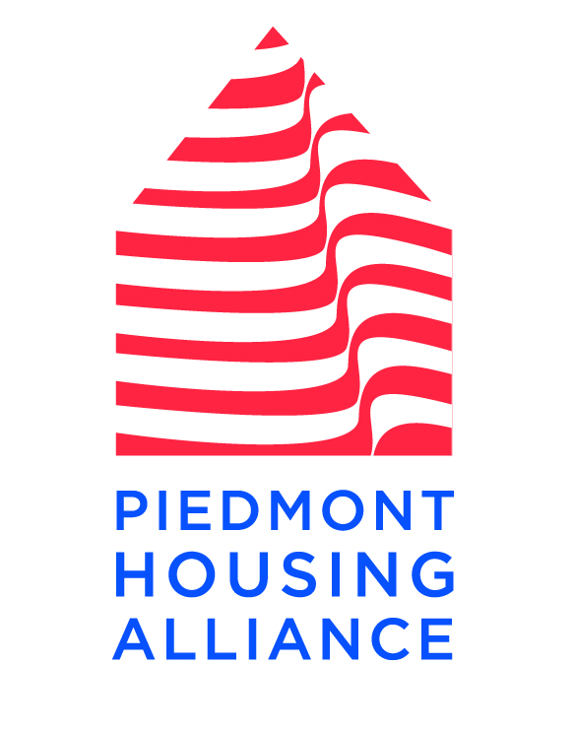
1215 East Market Street, Suite B, Charlottesville, VA 22902 www.piedmonthousingalliance.org

