Board of Directors Biographies

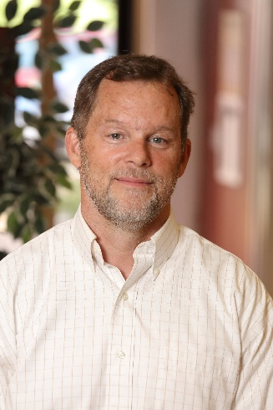
Frank Stoner, Board President
Frank Stoner began his board service with Piedmont Housing Alliance in 2015. He has lived in the Charlottesville area since 1984, and has worked in real estate development for nearly all of that time. Currently, Frank is a principal at Milestone Partners, a development management firm.

Frank’s commitment to affordable housing solutions dates back to a 1989 trip to India with former fellow-board member Satyendra Huja, who was then Charlottesville’s director of Planning and Community Development. Frank credits this trip with “opening [his] eyes and heart.” As a housing provider, Frank says he feels “a sense of responsibility to find sustainable solutions for the affordable housing challenge.” His longstanding professional involvement in producing market-rate housing has equipped him to understand and assist with many of the issues and challenges around safe, affordable housing. Through his work on Piedmont Housing’s board, Frank has appreciated the opportunity to connect with others who care deeply about the organization’s mission.

In addition to his work with Piedmont Housing, in the past Frank has served on the board at the Charlottesville Regional Chamber of Commerce, the Albemarle Housing Improvement Program, the Jefferson Area Board for Aging, and as a deacon at First Presbyterian Church. He currently serves on the board of the Free Enterprise Forum and as a member of the Jefferson School Community Partnership. Frank is a graduate of Southern Methodist University.

Barbara Brown Wilson, Board Vice President

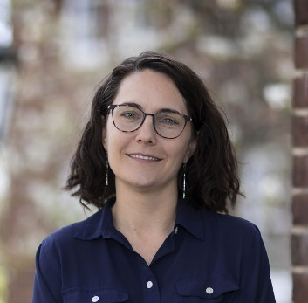
Barbara Brown Wilson joined the Piedmont Housing board in 2015. To date, Barbara has worked closely with Piedmont Housing leadership to identify opportunities for Charlottesville affordable housing residents to more actively engage in and shape their communities. Barbara had barely settled in to her new faculty position at UVA, having recently moved from the University of Texas at Austin, when she was invited to get to know Piedmont Housing.

Barbara is currently an assistant professor of Urban and Environmental Planning at UVA’s School of Architecture, and a co-founder of Design Futures, an annual student leadership forum bringing together a diverse spectrum of university students and faculty with leading practitioners to promote leadership and skill-building for students hoping to use design as a tool for social equity and positive change in underserved communities. While in Austin, she also co-founded the Austin Community Design and Development Center, a nonprofit that provides high-quality green design and planning services to low-income households and service organizations. She also served on the board of the Texas Low Income Housing Information Service, a statewide policy and advocacy organization, at the inception of the Texas Department of Housing and Community Affairs v. The Inclusive Communities Project Supreme Court case, which recently upheld the use of “disparate impact claims” under the Fair Housing Act.

Dave Paulson, Board Treasurer
Dave Paulson serves as Treasurer of the Piedmont Housing Alliance’s board of directors. A long-time affordable housing advocate, Dave has also served on the board of the Albemarle Housing Improvement Program and is a former chairman of the Albemarle Housing Committee. Dave joined Piedmont Housing’s board in 2015 after many years as a member of its Community Development Financial Institution (CDFI) committee. Originally transferring to Charlottesville during his commercial banking career for what he thought would be perhaps a few years, Dave and his wife fell in love with the area and have made it their home for more than two decades, raising their three children here.
Dave currently serves as the Chief Financial Officer at Eagle Corporation, a building materials company with operations throughout the mid-Atlantic. Dave believes passionately that a safe and affordable home is the necessary foundation for anyone to improve their economic circumstances and provide stability and opportunity for their children. He also believes this housing must be located near good schools and employment opportunities. Dave looks forward to helping Piedmont Housing continue its critical work of building more affordable rental housing units and providing home ownership opportunities for low-to-moderate income families in our area. Dave received an undergraduate liberal arts degree from Penn State, and holds an MBA from Indiana University’s Kelley School of Business.
Diana Burruss, Board Secretary
Diana Burruss has served as a Piedmont Housing Alliance board member since 2014. When Diana’s husband retired in 2011, they relocated from the New York City area to Louisa County, where they have family ties. Diana describes her transition as a “paradigm shift” — leaving a large urban area in the Northeast, where she worked as a Vice President at JP Morgan Chase in business services, to a largely rural area in central Virginia, where Diana has focused her energies on children and education.
Diana had past experience chairing the board of commissioners for a housing authority in Westchester County, New York. So, when Piedmont Housing sought someone to serve on the board from Louisa, Diana thought it would be a great opportunity to join together her past expertise and present passion, for local children and young families, to the benefit of her new community. Impressed by what she has seen Piedmont Housing accomplish in Charlottesville, Diana is excited to help find ways to connect even more families in surrounding counties with homebuyer workshops and other financial education programs with a focus on housing.
Diana currently works as an elementary school reading and math specialist in Louisa. She has volunteered as a child advocate through Piedmont CASA, and as Book Buddies reading tutor at Charlottesville’s Clark Elementary School. Diana holds a bachelor’s degree in marketing from Marymount College in Tarrytown, New York, and a master’s degree in leadership and organizational behavior from Mercy College in Dobbs Ferry, New York.

Marjorie Adam, Board Member
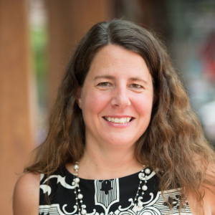
Marjorie Adam has served as a Piedmont Housing Alliance board member since 2015. Marjorie grew up in the Charlottesville area, and within a few years of graduating from college in Pennsylvania, found herself returning to her wonderful home town. Her mother, a realtor, welcomed her as an assistant in her business. That was more than 20 years ago – several years later, Marjorie’s brother joined the team as well.
From her many years working in real estate, Marjorie was familiar with the services that Piedmont Housing provides to the community, particularly down-payment assistance, educational programs, and the Workforce Housing Fund administered by Piedmont Housing for the Charlottesville Area Association of Realtors (CAAR). Marjorie’s real estate office is also located on Garrett Street, right near Friendship Court, and she appreciates Piedmont Housing’s commitment to supporting centrally located affordable housing. Marjorie says “it is a great joy to help find someone their first home or to help a family with life changes,” and this is what she sees Piedmont Housing doing every day through its service to the community.
In addition to her work for Piedmont Housing, Marjorie also serves as a board member for the Charlottesville Scholarship Program, and has served on the board of CAAR, as membership co-chair of Women United, and as president of McIntire Little League. She and her husband, Philippe, have two children – a son, who is an avid baseball player, and a daughter who plans to study art at the Maryland Institute College of Art, following her graduation from high school. Marjorie holds a bachelor’s degree, in journalism, from Susquehanna University.

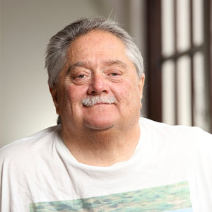
Jay Bartlow, Board Member
Jay Bartlow was born and raised in Charlottesville and has strong roots in the community. He came from a large family consisting of eight brothers and two sisters. Jay was a contractor and an avid motorcycle racer. In 1993, he suffered an accident that left him paralyzed, and when he was released from the hospital he was left desperately needing a place to live. Jay’s occupational therapist did some research on housing options and found that there was very little affordable housing for people with disabilities. Fortunately, they did find Monticello Vista Apartments, and in August of 1993, Jay moved in as one of Monticello Vista’s first residents and has lived there ever since. Jay stays busy drafting plans for private homeowners as well as contractors, since he had been working as a contractor prior to his accident and honed his skills while at the Woodrow Wilson Rehabilitation Center. Jay understands the dire shortage of affordable rental housing and the importance of Piedmont Housing Alliance creating, preserving, and managing more affordable housing.
(Note: his mother worked in the building before it was housing! The building dates back to 1928 when it became Henderson & Ervin, a shirt and underwear factory and then later a pajama factory where, ironically, Jay’s mother worked for many years. She worked there both before and after Jay was born until around 1967. “She’s my angel looking over me,” Jay said.)

Caroline Brennan, Board Member
Caroline Brennan has served on Piedmont Housing Alliance’s board of directors since 2010. Originally from the New York area, Caroline came to Charlottesville, in 2000, to pursue a master’s degree at the University of Virginia. Caroline currently works at UVA’s school of medicine as a grants coordinator. Her training, however, is as an environmental planner, “which is all about people and places and natural resources. And a lot about facilitation and bringing people together on tough issues. I am passionate about communities, social and environmental justice, ecology, and public health,” she says.
In 2004, Caroline was introduced to Piedmont Housing’s work when she became a first-time homebuyer in the first phase of Piedmont Housing’s 10th and Page neighborhood revitalization project. She is especially excited about Piedmont Housing’s work in combining energy efficiency and nontoxic building materials within the framework of affordable housing.
Before coming to Charlottesville, Caroline was a planning consultant for transportation projects. More recently, she served as Program Manager at UVA’s Institute for Environmental Negotiation, helping stakeholders collaborate on issues of natural resources, land use and public health. She also managed the Virginia Natural Resources Leadership Institute, and served as deputy director of UVA’s Center of Expertise for Superfund Site Recycling. Caroline holds a bachelor’s degree, in Environmental Design, from the University at Buffalo, and a master’s, in Urban & Environmental Planning, from UVA.

Roxanne Carter-Johnston
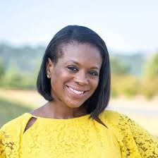
Roxanne Carter-Johnston is a Charlottesville native and currently resides in Fluvanna County where she has been for the past 16 years. She is a real estate agent at Nest Realty in Charlottesville. Aside from serving on our Board of Directors, she is also a member of the Fluvanna County Habitat for Humanity Board of Directors, Fluvanna Co. Volunteers Advisory Committee and is involved in the Tandem Friends School Admissions Panel and Tandem Giving Committee.

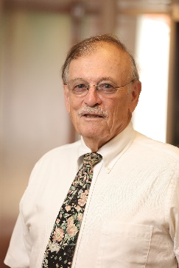
Ron Enders, Board Member
Ron Enders has served as a member of Piedmont Housing Alliance’s board of directors since 1996. Ron originally moved to Nelson County, outside of Charlottesville, in the early 1970s to help found an alternative community in Afton, which is now called Shannon Farm Community.

For 21 years, Ron served people with disabilities in Charlottesville as the President of WorkSource Enterprises. Ron was also instrumental in the development of JAUNT (Jefferson Area United Transportation) and the Independence Resource Center, both of which provide support to community members with physical and sensory disabilities. Ron also served on the Advisory Board of the Thomas Jefferson Housing Improvement Corporation (TJHIC), prior to its name change to Piedmont Housing Alliance. Through his work with these organizations, Ron saw that housing was an issue for many vulnerable members of our community, and he feels fortunate to have had the opportunity through his work with Piedmont Housing to participate in the provision of affordable housing in the area.
In addition to his leadership at Piedmont Housing, Ron helped found and still serves as treasurer of Friends of Nelson, working to protect Nelson County from Dominion Power’s proposed Atlantic Coast Pipeline. He is also one of the founders of the Virginia Blue Ridge Railway Trail Foundation, a grassroots group with the ambitious vision of creating a trail connecting the Blue Ridge Parkway and the James River. Seven miles of the rails-to-trails project is now open on the border between Nelson and Amherst Counties. An avid cyclist, Ron has traveled by bicycle on extended trips in many countries around the world. In recent years, he has continued these winter travels, but now foregoes the bicycle in favor of other modes of transportation. He recently returned from a 9 week trip to Morocco, Gibraltar and the South of Spain. Ron holds a business degree from Wake Forest University, with a
concentration in accounting.

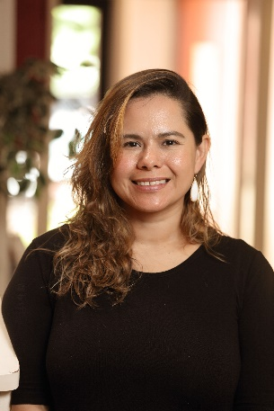
Geraldina Gonzalez, Board Member
Geraldina joined the Piedmont Housing Board of Directors in 2019. As homebuyer, she used Piedmont Housing's Housing Counseling services to help purchase her first home. Geraldina first came to Charlottesville from El Salvador 16 years ago in hopes of providing herself with better opportunities for a successful future, and she’s now a US Citizen. She works full time as a server at Hamiltons’ and also works in the café at Feast.

Victoria Lewis, Board Member
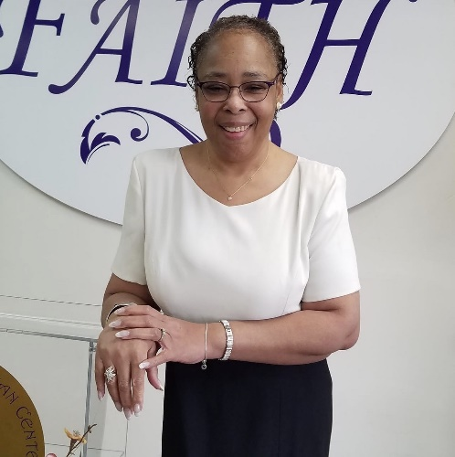
Victoria Lewis describes herself as a passionate person that takes “tremendous opportunity in helping wherever I can.” She has over 15 years of experience in property management.
.

Beth Meyer, Board Member
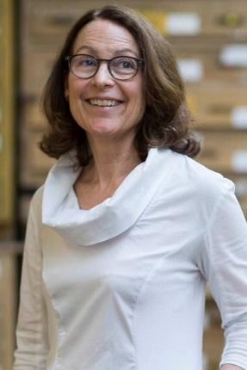
Beth Meyer’s service on the Piedmont Housing Alliance Board of Directors began in 2017. She brings to the Board decades of design research into the impacts of government-sponsored urban renewal on Charlottesville’s residents and their communities. Meyer views this history through the lens of a landscape architect as interested in the social as well as the ecological aspects of urban landscape form and experience.

Meyer first lived in Charlottesville in the mid-1970s when she attended the University of Virginia’s School of Architecture. After graduate school at Cornell University and the University of Virginia, Meyer worked as a landscape architect planning and designing public spaces, parks and plazas for campuses and downtowns up and down the East Coast of the United States. She has a particular interest in how the design of everyday urban landscapes (such as streets, sidewalks, yards, gardens and parks) reveal and affirm community values, meanings and activities while simultaneously improving individual health and community well-being.

In the mid-1990s, Meyer returned to Charlottesville to teach at the University of Virginia. While she has lived up and down the East Coast of the United States and in Puerto Rico, Meyer considers Charlottesville home. In addition to her work at the University of Virginia, Meyer has served on local advisory committees concerned with urban design and planning, including the Charlottesville PLACE Design task force and the Albemarle County DISC Growth Management task force. In 2012, President Obama appointed her to a national design review and advisory board: the U.S. Commission of Fine Arts.

Two years ago, when Meyer was Dean of the UVA School of Architecture, she founded the Center for Cultural Landscapes as a collaborative hub for scholars and practitioners seeking to create new models for cultural landscape research, interpretation, preservation and adaptive use. The Center’s first major symposium, “Race and Public Space: Commemorative Practices in the American South,” took place in March, 2017. The speakers critically examined the history of civil war and civil rights monuments in public spaces as well as introduced contemporary approaches to redesigning public spaces to make them more inclusive.

Crystal Napier, Board Member
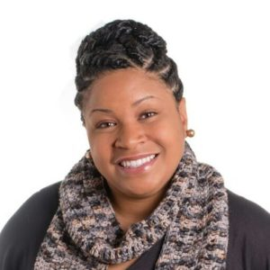
Crystal Napier has served as a Piedmont Housing Alliance board member since January 2015. Originally from Afton, Crystal came to the Charlottesville area as a University of Virginia undergraduate, and lives in Albemarle County. For 10 years, Crystal worked locally in banking management. While working toward her MBA, Crystal found her passion of empowering women through flattering clothing designs and styles. In 2014, Crystal launched a local entrepreneurial venture, Renee’s Boutique, specializing in “professional and casual clothing for the curvy woman,” while also offering customized styles for every woman.

Crystal knew about Piedmont Housing’s services from her years working in banking, and understood how much these services helped area home buyers. Having purchased her first home at age 22, Crystal appreciates the challenges first-time owners face, and problems of housing affordability in Albemarle County. While participating in the Center for Nonprofit Excellence’s board academy in 2014, Crystal met a member of Piedmont Housing’s staff who invited her to learn more about the organization. She has high praise for the staff as a whole, and the successes of their counseling programs, as well as large-scale projects like the Friendship Court redevelopment.

Although Renee’s Boutique, still in its early years, is her primary focus, Crystal is also the part-time Marketing Coordinator for Charlottesville’s Jefferson School City Center – a recently restored city landmark and the heart of Charlottesville’s African American community for generations. She is also active with the Chamber Business Diversity Council (formerly the Minority Business Council) of the Charlottesville Regional Chamber of Commerce, and a financial mentor for Seed Planters Dream Builder Academy, helping to support and advise other women in business. Crystal also supports the American Cancer Society, March of Dimes (High Heels for Hopes), and Girl Scouts of America. She holds a bachelor’s degree, in Government and African American Studies, from the University of Virginia, and received her MBA from Liberty University.

Oliver Platts-Mills, Board Member
Oliver Platts-Mills served on Piedmont Housing Alliance’s board of directors from 2011 to 2014, and rejoined the board early in 2016 following a year of overseas travel. Oliver grew up in the Charlottesville area, attending Albemarle County public schools. After college, he returned to pursue a master’s degree at the University of Virginia. Oliver currently works in various aspects of real estate — development, renovation, and property management. When Oliver was in graduate school, he and his wife renovated their first house together, which grew into his current business.
Oliver first learned of the Piedmont Housing Alliance when he and his wife received housing counseling prior to purchasing their first home. “The advice we received from Piedmont Housing was excellent,” he says, “and helped us make sensible decisions around a major decision in our lives.” Developing and managing rental properties in the city has exposed Oliver to the lack of affordable housing options in Charlottesville, as well as the intense pressure being placed upon existing options. He believes that, as a community, “we ought to be unsatisfied until all of our fellow residents are able to thrive. Housing security is often the bedrock of how struggling families find ways to regain their footing.” Serving on Piedmont Housing’s board has enabled Oliver to support the provision of these essential services.
Oliver enjoys that his work on Piedmont Housing’s board informs his daily work in real estate, and vice-versa. He is a graduate of Western Albemarle High School, and earned a bachelor’s degree from Wesleyan University, and a master’s degree, in Systems Engineering, from the University of Virginia.
Najeeba Popal, Board Member
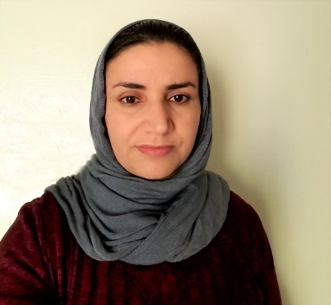
Najeeba Popal joined the Piedmont Housing Alliance Board of Directors in January 2019. She brings experience in finance and experience as a resident of Friendship Court Apartments. She graduated from economic faculty in Afghanistan in 2009, and worked in Finance from 2009-2014. Seeking peace and safety, she moved to the United States with her husband and one year old daughter in 2015, and one month later they welcomed their second child. The family found a home at Friendship Court Apartments, and Najeeba has become involved in the community. She is also a part-time community interpreter for the International Rescue Committee and enjoys teaching Afghan cooking classes.

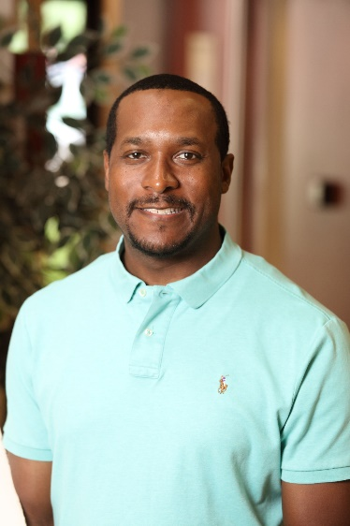
Robert Scott, Board Member
Robert Scott serves as a physical scientist at the National Ground Intelligence Center in Charlottesville. Robert, a native of Suffolk, Virginia, completed a Master’s of Engineering at the University of Virginia and holds a degree in Chemistry from Norfolk University. Additionally, Robert is the owner of Scott Photography, LLC, where he specializes in portraiture and event photography. Robert’s interest in joining the Piedmont Housing Alliance Board stemmed from the desire to see the housing needs of the community met. In his spare time, Robert enjoys spending time with his family and playing golf. He lives with his wife and two children in Zion Crossroads, VA.

Ken Shevlin, Board Member
Ken Shevlin joined the board of Piedmont Housing Alliance in July, 2017. Ken is an attorney with Williams Mullen and brings to the board expertise in commercial real estate law.
He earned his Juris Doctor from the University of Virginia School of Law, where he served as editor-in-chief of the Virginia Environmental Law Journal. He holds an M.Phil. in political thought and intellectual history from the University of Cambridge and a B.A. in political science, cum laude, from Yale.
Ken’s professional experience has highlighted for him the need for affordable and mid-tier housing in the Charlottesville and the surrounding counties. His interest in affordable housing work stems from a belief in the benefits of creating a community where everyone can live side-by-side. Previously, Ken has devoted volunteer time to serving the homeless and Habitat for Humanity.
With many friends and professional connections on the Piedmont Housing Alliance board, Ken was personally inspired to get involved in an organization making a big impact in affordable housing.
In addition to his volunteer work with Piedmont Housing, Ken is secretary of the board of directors of The Paramount Theater and was co-chair of the Urban Land Institute Charlottesville Young Leaders Group from 2016-2017.

